Business Question and Visualization Report
Field | Details
Team ID | Individual
Project Name | Smartphone Usage, Digital Addiction & Well-Being Analytics
Maximum Marks | 5 Marks

Visualization development refers to the process of creating graphical representations of data to facilitate understanding, analysis, and decision-making. The goal is to transform complex datasets into visual formats that are easy to interpret, enabling users to gain insights and make informed decisions. Visualization development involves selecting appropriate visual elements, designing layouts, and using interactive features to enhance the user experience. This process is commonly associated with data visualization tools and platforms, and it plays a crucial role in business intelligence, analytics, and reporting.
Business Questions and Visualisation
The process involves defining specific business questions to guide the creation of meaningful and actionable visualizations in Power BI. Well-framed questions help in identifying key metrics, selecting relevant data, and building visualization components that provide deep, actionable insights into user behaviors, stress triggers, and digital health patterns.
Report Framework
1. What are the average daily screen time hours across different genders?
- Visualization: Bar chart comparing average daily_screen_time_hours by gender.
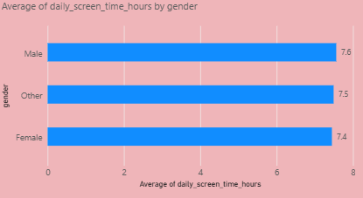
2. How do social media hours compare to gaming hours across different age groups?
- Visualization: Clustered column chart showing social_media_hours and gaming_hours grouped by age.
- 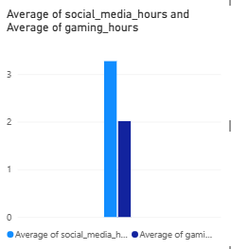
3. What is the relationship between daily screen time and sleep hours?
- Visualization: Scatter plot mapping daily_screen_time_hours against sleep_hours.
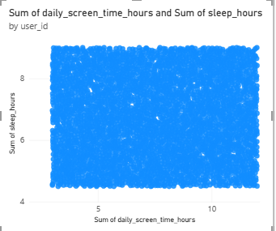
4. How does the count of transaction id by addiction level?
- Visualization: Bar chart showing the count of tranction_id by addiction_level category.
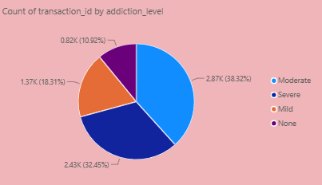
5. Which addiction levels have the highest number of app opens per day?
- Visualization: Column chart displaying average app_opens_per_day across different addiction_level categories.
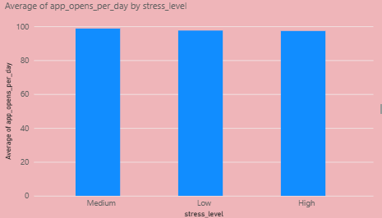
6. How is user screen time distributed between regular daily use and weekend use?
- Visualization: Line chart comparing daily_screen_time_hours and weekend_screen_time for users.
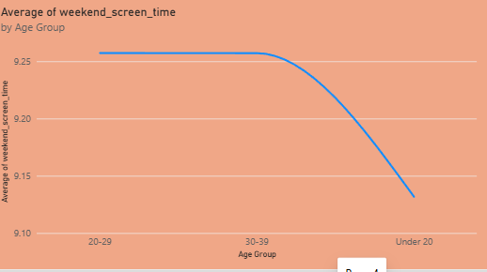
7. Does a higher addiction level correlate with a negative impact on academic or work life?
- Visualization: Stacked column chart showing the count of academic_work_impact (Yes/No) grouped by addiction_level.
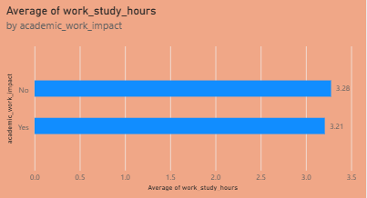
8. What proportion of the dataset is flagged with the final addicted label?
- Visualization: Pie chart showing the percentage distribution of the addicted_label (0 vs 1).
